**Task 1: ( 15 Basic Docker Commands ):**

1. **docker –version:-**

This command is used to get the currently installed version of docker

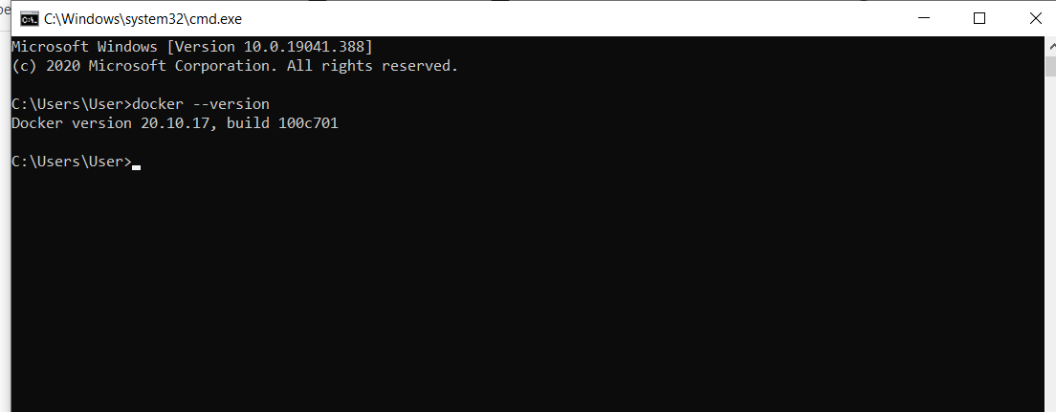

1. **docker pull :-**

**docker pull <image name>**

This command is used to pull images from the **docker repository.**

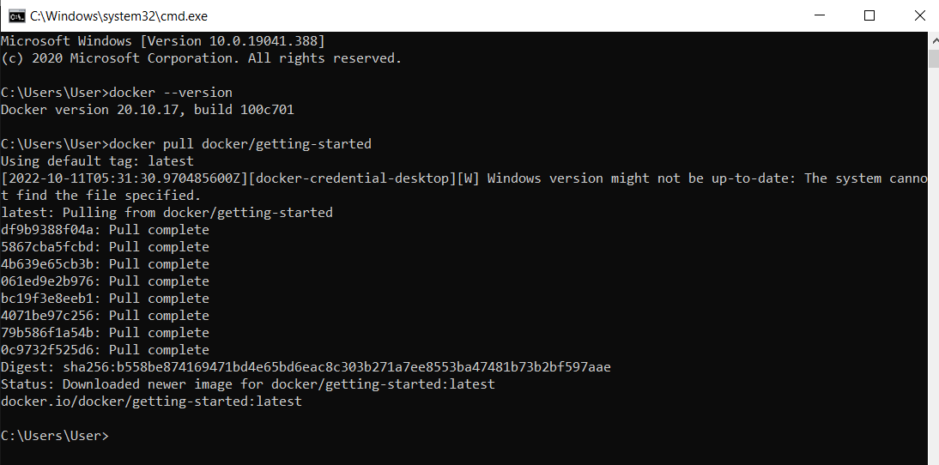

1. **docker images:-**

This command is used to check how many images we created.

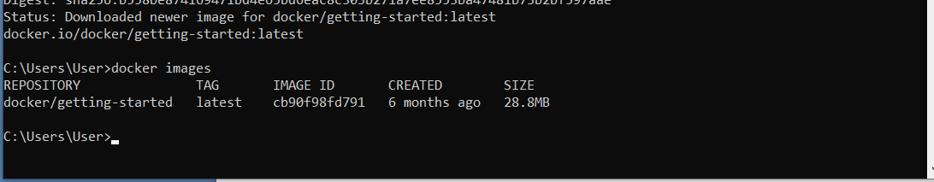

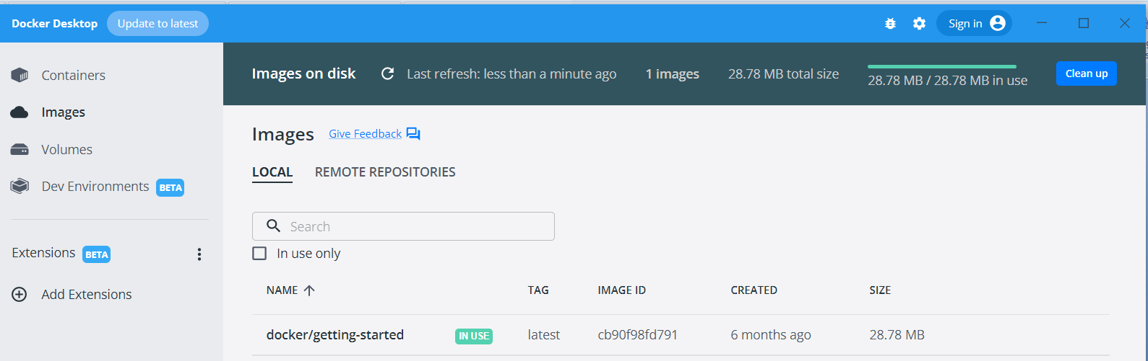

**4 docker run:-**

**docker run -it -d <image name>**

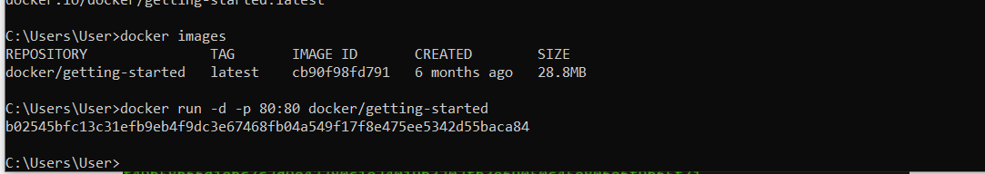 This command is used to create a container from an image.

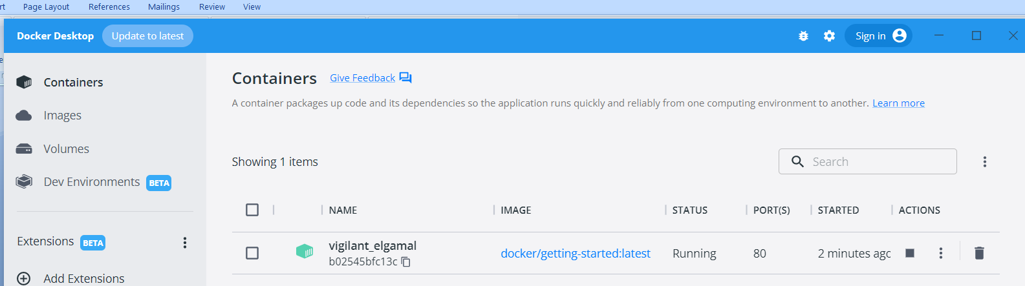

# 5. ****docker ps:-****

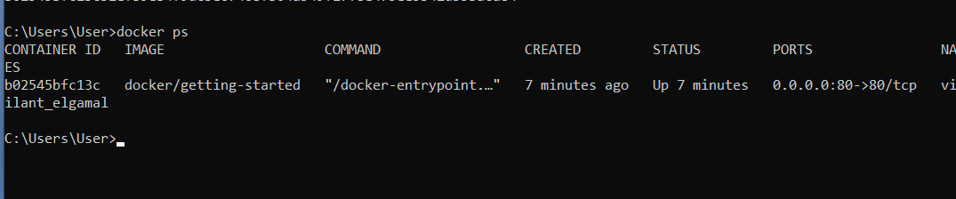This command is used to list the running containers

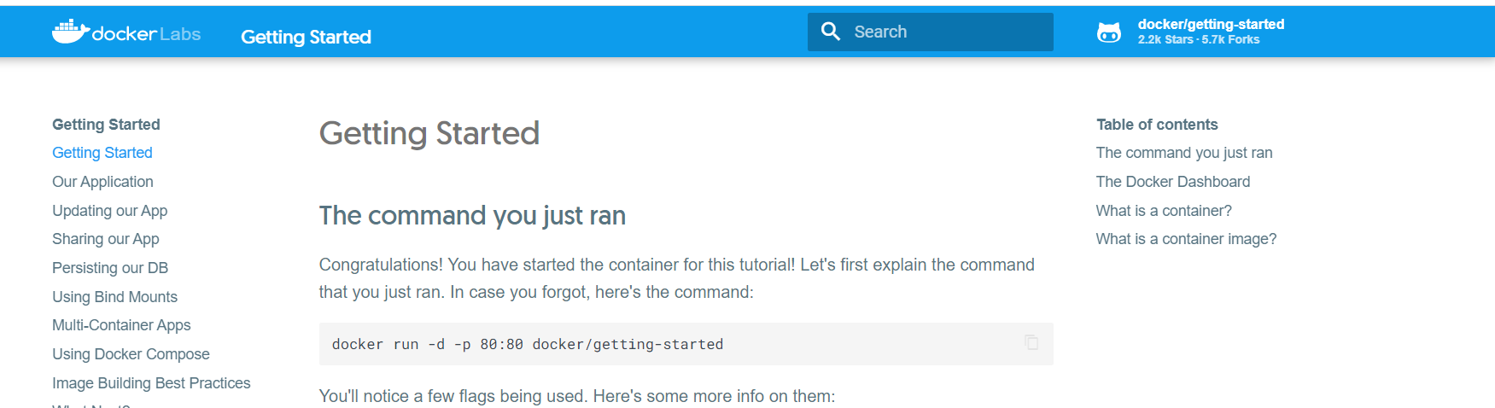

**6. docker ps –a:-**

This command is used to show all the running and exited containers.

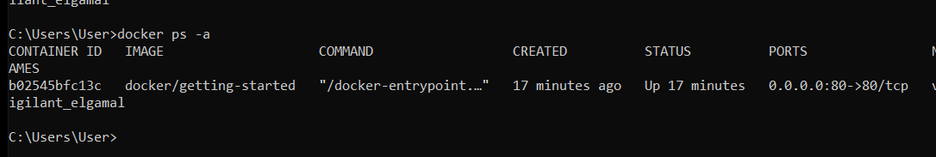

# 7.  ****docker network ls:-****

This command in docker lists the details of all the network in the cluster.

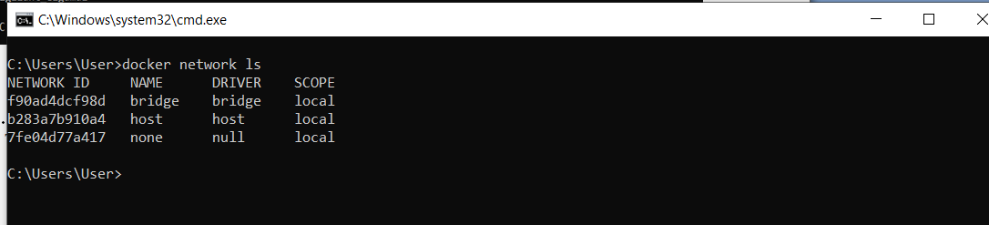

**8.docker info:-**

This command is used Get detailed information about docker installed on the system including the kernel version, number of containers and images.

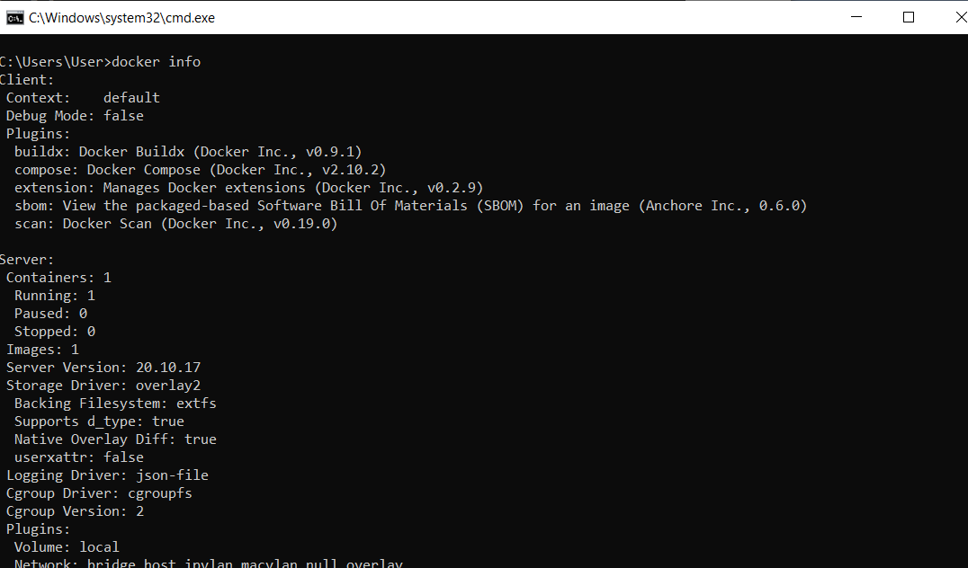

**9.docker logs:-**

Show the logs of the docker container with contained id mentioned in the command.

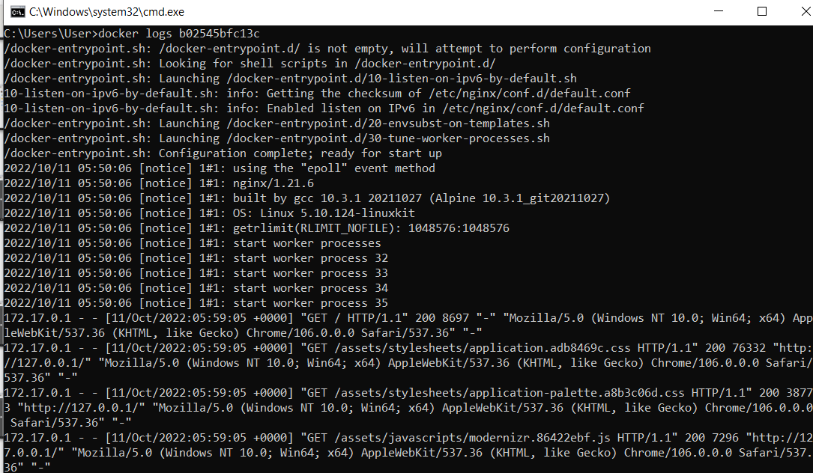

**10.docker start:-**

This command in docker starts the docker container with container id mentioned in the command**.**

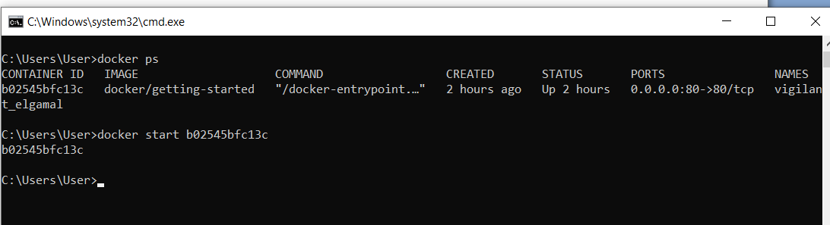

**11.docker stop:-**

This command is used to stop the docker container.

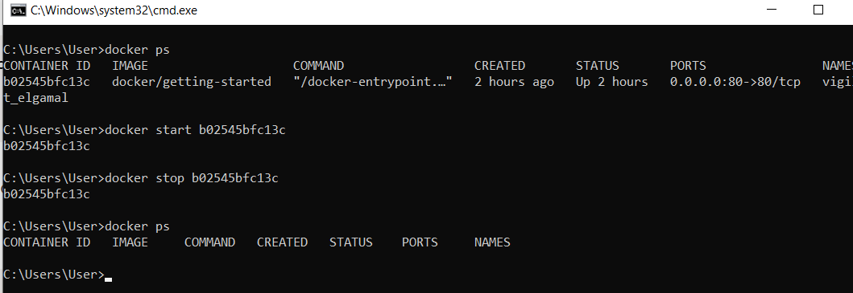

**12.Restart Docker:-**

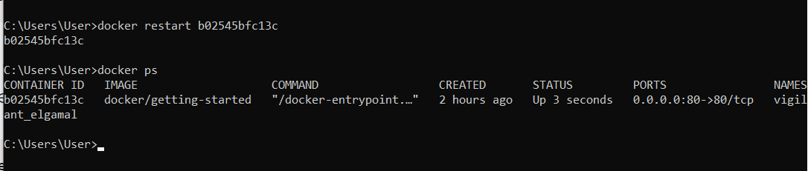This command is used to restart the docker container.

**13.docker kill:-**

This command is used to stop docker container immediately.

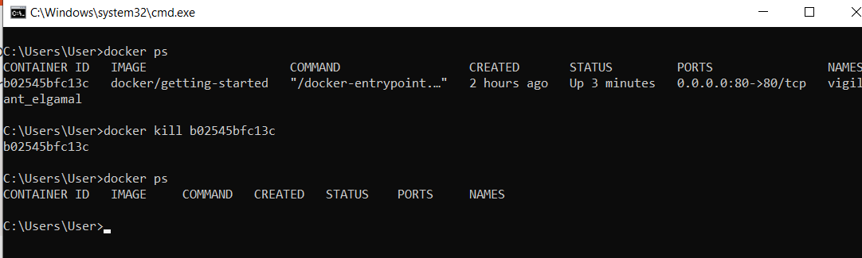

**14. Remove docker container:-**

This command is used to remove docker container with the help of container_id.

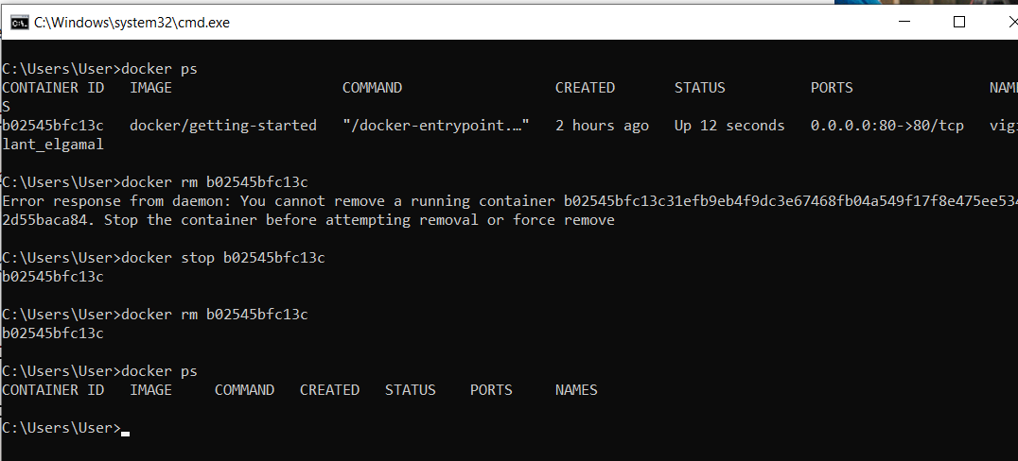

**15. Searching image:-**

This command is used to search docker image on docker hub.

